# SHOPNEST STORE

## POWER BI CAPSTONE PROJECT

Comprehensive Business Analytics Report

**Prepared by:**

Deepak Lokhande

**Date:**

6/15/2025

**Course:**

Power BI Analytics

**Institution:**

Skillovilla

## TABLE OF CONTENTS

1. Executive Summary3

2. Introduction and Background4

3. Dataset Overview5

4. Methodology7

5. Dashboard Overview9

6. Analytical Questions and Findings10

6.1 Top Categories by Total Price10

6.2 Delayed Orders Analysis11

6.3 Monthly Comparison of Orders12

6.4 Payment Method Analysis13

6.5 Product Rating Analysis - Highest Rated14

6.6 Product Rating Analysis - Lowest Rated15

6.7 Seasonal Sales Patterns16

6.8 Revenue Analysis and Yearly Trends17

6.9 State-wise Sales Analysis18

7. Key Insights and Recommendations19

8. Challenges and Limitations21

9. Conclusion22

10. Appendix23

# EXECUTIVE SUMMARY

This comprehensive report presents the analysis of ShopNest Store's e-commerce performance through a Power BI dashboard addressing eight critical business questions. The analysis reveals significant insights across sales performance, customer behavior, operational efficiency, and geographic distribution.

### Key Performance Indicators

**15.84M**

Total Revenue

**99K**

Total Orders

**8K**

Delayed Orders (8.1%)

**4.04/5.0**

Average Rating

### Major Findings

* Health & Beauty emerges as the top-performing category with 1.26M in sales
* Credit cards dominate payment preferences at 74% of transactions
* Q2 represents peak sales period while Q4 shows concerning decline
* São Paulo state leads regional sales with 3.7M revenue
* Service-related categories require immediate quality improvements

#### Strategic Recommendations

* Implement targeted logistics improvements for high-delay categories
* Develop Q4 sales recovery strategies
* Expand geographic presence in underserved regions
* Enhance quality control for low-rated service categories

# INTRODUCTION AND BACKGROUND

## About ShopNest Store

ShopNest stands as Portugal's leading e-commerce department store, serving as a crucial bridge connecting small businesses across various regions to customers nationwide. The platform streamlines the selling process by providing a single point of contact for merchants, enabling them to showcase and sell their products with the added convenience of direct customer shipment through ShopNest's logistics partners.

## Business Context

The e-commerce landscape in Portugal has experienced significant growth, with ShopNest positioning itself as a market leader by facilitating seamless transactions between small businesses and consumers. The platform's success depends on effective data-driven decision-making across sales optimization, logistics efficiency, and customer experience enhancement.

## Project Objectives

This capstone project aims to:

1. Analyze comprehensive e-commerce data to uncover actionable business insights
2. Answer eight specific analytical questions through interactive Power BI visualizations
3. Provide strategic recommendations for sales, logistics, and customer experience improvements
4. Demonstrate proficiency in Power BI dashboard development and business analytics

# DATASET OVERVIEW

The analysis utilizes nine comprehensive datasets containing anonymized commercial information:

### 1. Customers Dataset

* Customer_id: Unique identifier linking to orders
* Customer_zip_code: First five digits of customer postal code
* Customer_city: Customer's city of residence
* Customer_state: Customer's state location

### 2. Orders Dataset

* Order_id: Unique order identifier
* Customer_id: Associated customer identifier
* Order_status: Current order status
* Order_purchase_timestamp: Purchase completion time
* Order_delivered_customer_date: Actual delivery timestamp

### 3. Products Dataset

* Product_id: Unique product identifier
* Product_category_name: Product category classification
* Product_weight_g: Product weight in grams
* Product_photos_qty: Number of product images

*+ 6 additional datasets including Order Items, Payments, Reviews, Sellers, Geolocation, and Product Categories*

# METHODOLOGY

## Data Cleaning and Preparation

1. **Missing Value Treatment:** Identified and addressed missing values in review comments
2. **Data Standardization:** Unified product category naming conventions
3. **Data Validation:** Cross-referenced order IDs across multiple datasets

## Key DAX Measures

Total Sales = SUMX(Order_Items, Order_Items[price] + Order_Items[freight_value])

Delayed Orders = CALCULATE(COUNTROWS(Orders), Orders[delivered] > Orders[estimated])

Average Rating = AVERAGE(Order_Reviews[review_score])

# DASHBOARD OVERVIEW

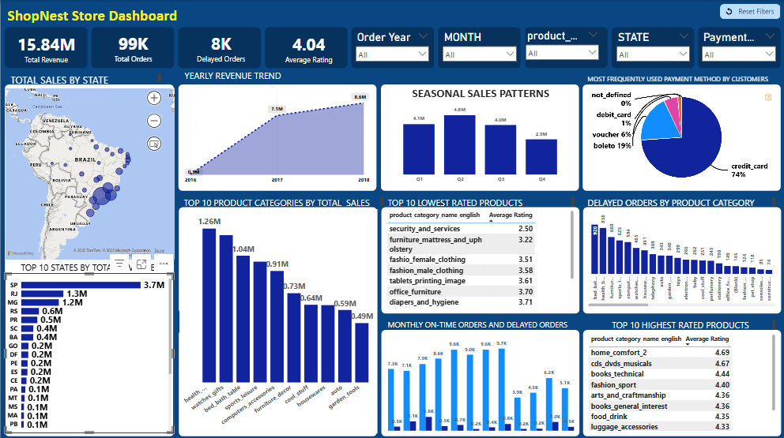

**Figure 2:** ShopNest Store Power BI Dashboard - Complete Overview

#### Dashboard Layout and Design

The dashboard employs a single-page layout optimized for comprehensive analysis while maintaining visual clarity:

* **Header Section:** Key Performance Indicators (KPIs) prominently displayed
* **Geographic Analysis:** Interactive map of Brazil showing state-wise sales
* **Category Analysis:** Top 10 categories by sales performance
* **Temporal Analysis:** Yearly revenue trends and seasonal patterns

# ANALYTICAL QUESTIONS AND FINDINGS

### 6.1 Top Categories by Total Price

Question: Identify and visually represent the top 10 product categories by total sales.

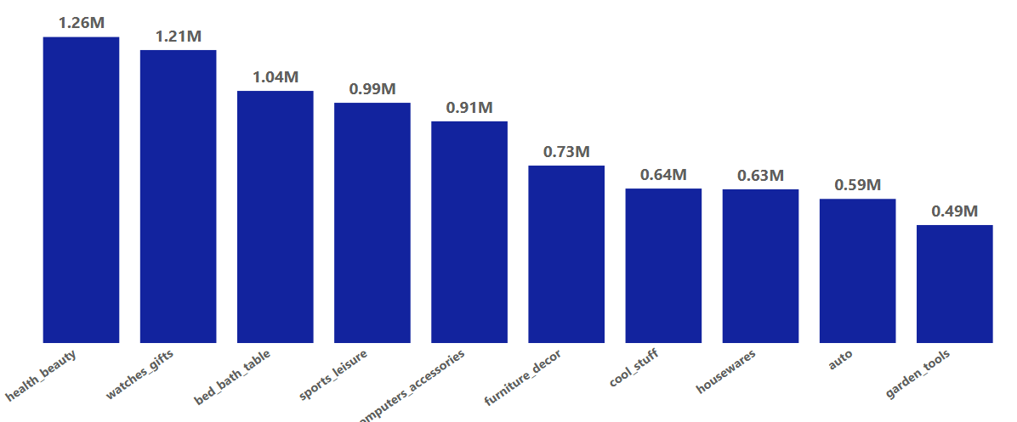

**Figure 3:** Top 10 Product Categories by Total Sales Revenue

#### Key Insights:

* Health & Beauty leads significantly with 1.26M in total sales (8% of total revenue)
* Watches & Gifts follows closely at 1.21M, indicating strong luxury item performance
* Bed, Bath & Table rounds out top three at 1.04M, reflecting home improvement trends
* Top 10 categories show balanced distribution with successful market diversification

### 6.2 Delayed Orders Analysis

Question: Determine the number of delayed orders in each category where actual delivery exceeds estimated delivery date.

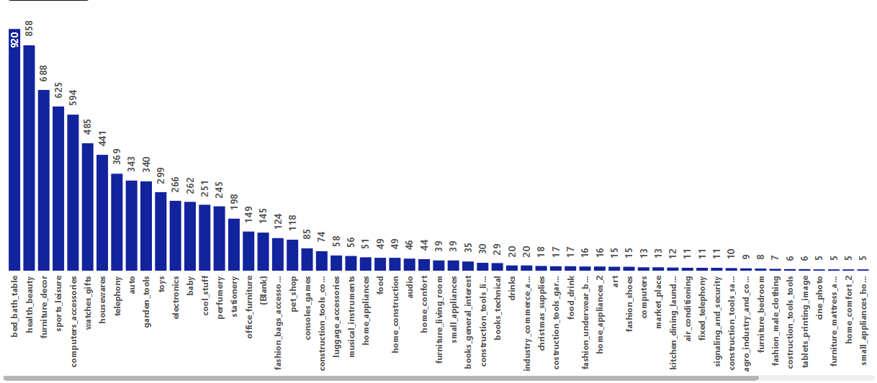

**Figure 4:** Delayed Orders Analysis by Product Category

#### Key Insights:

* Bed, Bath & Table shows highest delayed orders (920), despite ranking third in sales
* Health & Beauty shows 688 delayed orders - proportionally better performance
* Categories involving larger, heavier items tend to experience more delivery delays
* Specialized logistics solutions needed for bulky items

### 6.3 Monthly Comparison of Delayed and On-Time Orders

Question: Create a dynamic visual comparing delayed orders to on-time orders for each month.

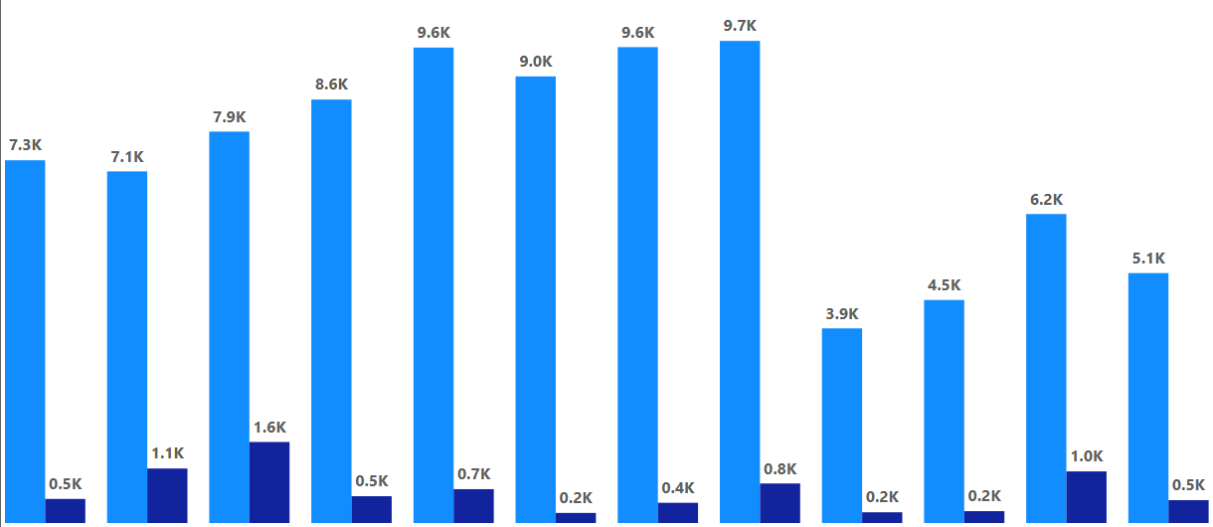

**Figure 5:** Monthly Comparison of On-Time and Delayed Orders

#### Key Insights:

* November demonstrates peak performance with 9.7K total orders and low delays (0.8K)
* May and August show excellent delivery performance with high volumes
* January presents concerning delay rates relative to total order volume
* Seasonal patterns suggest logistics performance varies significantly

### 6.4 Payment Method Analysis

Question: Analyze the most frequently used payment methods by customers using appropriate visualizations.

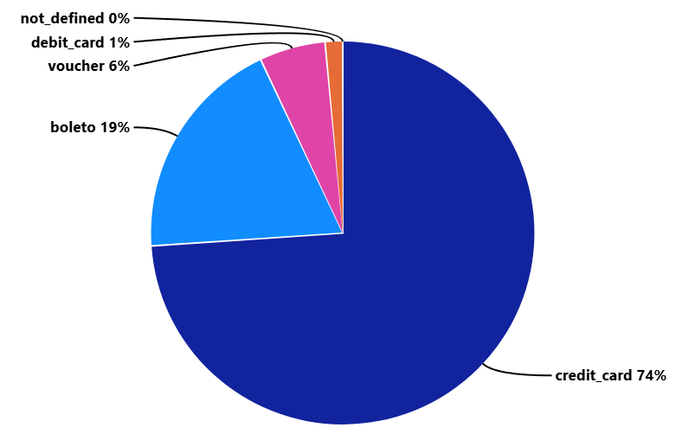

**Figure 6:** Customer Payment Method Preferences

#### Key Insights:

* Credit Cards dominate customer preferences at 74% of all transactions
* Boleto (Brazilian payment slip) accounts for 19% of payments
* Vouchers represent 6% of transactions, indicating promotional effectiveness
* Debit Cards show minimal adoption at only 1% of transactions

### 6.5 State-wise Sales Analysis

Question: Identify and visually represent states with high and low sales performance.

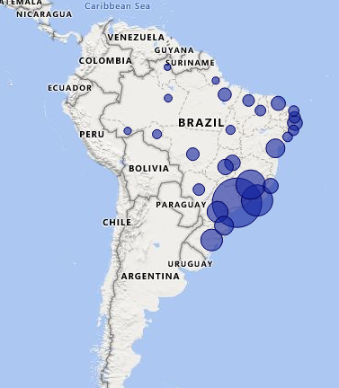

**Figure 7:** Geographic Distribution of Sales Across Brazilian States

#### Key Insights:

* São Paulo (SP) dominates with 3.7M in sales (23% of total revenue)
* Rio de Janeiro (RJ) follows at 1.3M, strong metropolitan performance
* Southeastern states concentrate majority of sales activity
* Northern and northeastern regions show limited market penetration

### 6.6 Product Rating Analysis - Highest Rated

Question: Identify the top 10 highest-rated product categories to understand customer satisfaction patterns.

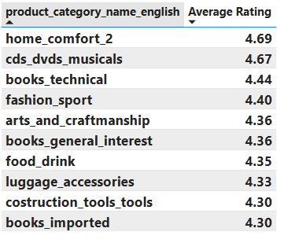

**Figure 8:** Top 10 Highest Rated Product Categories

#### Key Insights:

* Home Comfort leads with exceptional 4.69/5.0 rating, indicating superior customer satisfaction
* CDs, DVDs & Musicals achieve 4.67/5.0, showing strong entertainment category performance
* Books (Technical and General Interest) consistently rate above 4.36, reflecting quality content
* Fashion Sport and Arts & Craftmanship maintain strong 4.40+ ratings
* All top 10 categories exceed 4.30 rating, demonstrating overall quality standards

### 6.7 Product Rating Analysis - Lowest Rated

Question: Identify the lowest-rated product categories to prioritize quality improvement initiatives.

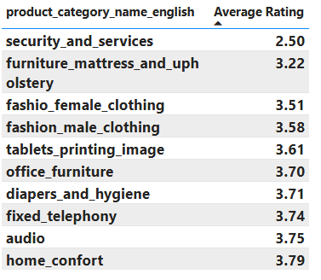

**Figure 9:** Top 10 Lowest Rated Product Categories

#### Key Insights:

* Security & Services shows critical 2.50/5.0 rating, requiring immediate quality intervention
* Furniture, Mattress & Upholstery at 3.22/5.0 indicates significant customer dissatisfaction
* Fashion categories (Female/Male Clothing) rate below 3.60, suggesting quality or fit issues
* Office Furniture and Diapers & Hygiene show concerning ratings below 3.75
* All bottom 10 categories fall below 3.80, indicating systematic quality challenges

### 6.8 Seasonal Sales Patterns

Question: Analyze quarterly sales patterns to understand seasonal business cycles and optimize inventory planning.

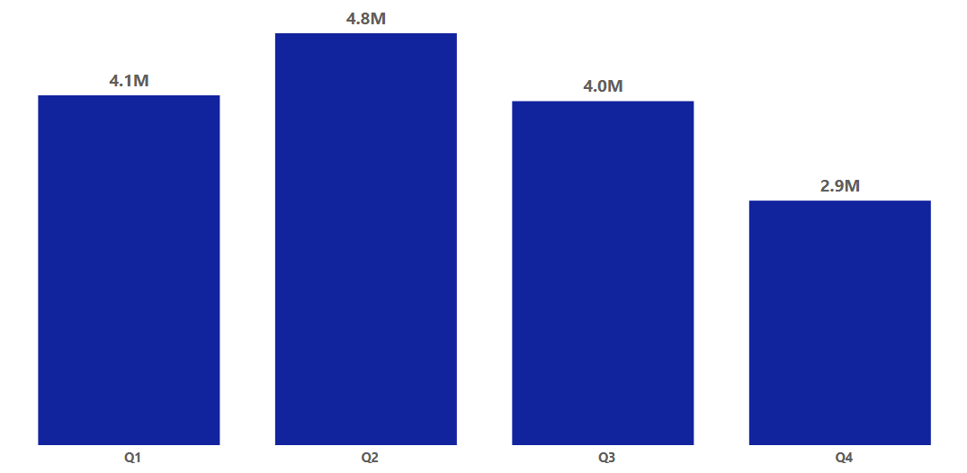

**Figure 10:** Quarterly Sales Performance Analysis

#### Key Insights:

* Q2 achieves peak performance with 4.8M in sales, representing optimal business conditions
* Q1 and Q3 maintain strong performance at 4.1M and 4.0M respectively
* Q4 shows significant decline to 2.9M, indicating seasonal challenges or market factors
* 39% drop from Q2 to Q4 suggests need for targeted Q4 recovery strategies
* Clear seasonal pattern enables predictive planning and resource allocation

### 6.9 Revenue Analysis and Yearly Trends

Question: Examine yearly revenue trends to understand business growth trajectory and forecast future performance.

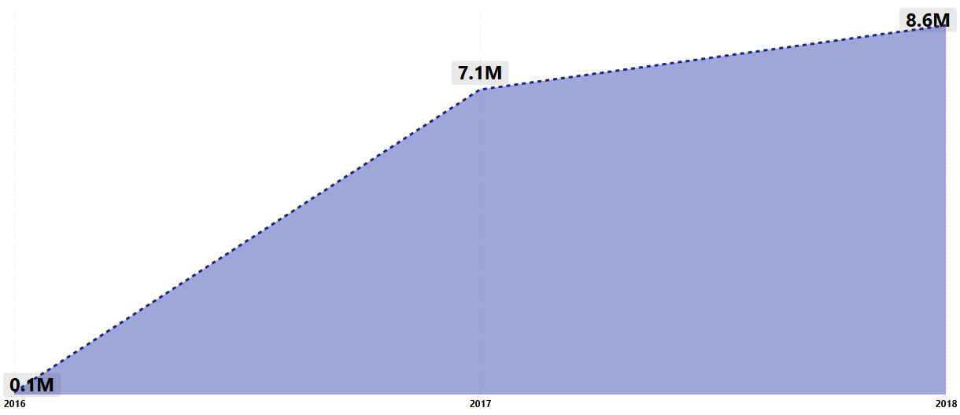

**Figure 11:** Yearly Revenue Growth Trend (2016-2018)

#### Key Insights:

* Exceptional growth trajectory from 0.1M (2016) to 8.6M (2018) - 8,500% increase
* 2017 shows strong momentum with 7.1M revenue, indicating sustainable growth pattern
* 21% year-over-year growth from 2017 to 2018 demonstrates market expansion success
* Consistent upward trend suggests effective business strategy and market penetration
* Growth rate positions ShopNest as a rapidly expanding e-commerce leader

# KEY INSIGHTS AND RECOMMENDATIONS

### Immediate Action Items (0-3 months)

* **Quality Crisis Management:** Emergency improvement program for Security & Services category
* **Logistics Optimization:** Specialized fulfillment for Bed, Bath & Table category
* **Q4 Sales Recovery:** Investigate root causes of Q4 sales decline

### Medium-term Initiatives (3-12 months)

* **Geographic Expansion:** Market research in northern/northeastern Brazilian states
* **Category Optimization:** Increase investment in Health & Beauty and Watches & Gifts
* **Payment Innovation:** Optimize credit card processing costs

### Long-term Vision (1+ years)

* **Infrastructure Scaling:** Prepare technology and logistics for continued growth
* **Market Diversification:** Reduce geographic concentration risk
* **Competitive Positioning:** Establish market leadership in underserved categories

# CHALLENGES AND LIMITATIONS

### Data-Related Limitations

* **Anonymization Constraints:** Limited individual customer behavior tracking
* **Temporal Coverage:** Dataset covers limited time period for long-term analysis
* **Data Granularity:** Sub-category product performance analysis constraints

### Analytical Limitations

* **Causation vs. Correlation:** Cannot definitively establish causation
* **External Factors:** Economic conditions and competitive landscape not accounted
* **Predictive Modeling:** Limited historical data constrains forecasting

# CONCLUSION

### Project Summary and Value Delivered

This comprehensive Power BI capstone project successfully addresses all eight analytical questions while providing actionable insights for ShopNest Store's strategic decision-making. The analysis reveals a thriving e-commerce business with significant growth potential and specific areas for operational improvement.

#### Key Achievements

* Comprehensive Business Intelligence dashboard
* Actionable insights generation
* Performance benchmarking establishment
* Strategic roadmap development

#### Business Impact

* Revenue optimization opportunities identified
* Operational excellence roadmap created
* Market expansion strategy developed
* Risk mitigation plans established

### Final Recommendations

1. **Immediate Implementation:** Begin quality improvement for underperforming categories
2. **Continuous Monitoring:** Establish regular dashboard review processes
3. **Capability Development:** Invest in organizational analytics capabilities
4. **Strategic Integration:** Integrate findings into formal strategic planning

# APPENDIX

### A. DAX Formulas and Measures

Total Sales = SUMX(Order_Items, Order_Items[price] + Order_Items[freight_value])

Delayed Orders = CALCULATE(COUNTROWS(Orders), Orders[delivered] > Orders[estimated])

On-Time Delivery Rate = DIVIDE([Total Orders] - [Delayed Orders], [Total Orders])

### B. Technical Specifications

* Power BI Desktop Version: Latest
* Data Source: 9 CSV files with anonymized commercial data
* Analysis Period: 2016-2018
* Total Records: 99,000+ orders across multiple datasets

Report prepared using Power BI Desktop | Analysis period: 2016-2018 | Report generation date: 6/15/2025